Social Network Analysis of Misinformation vs Non-Conspiracy Twitter Graphs

Student Information
- Student Name: Bassel Yasser Abdelsamea
- Student ID: 2205015
- Lab Title: Social Network Analysis of WICO Twitter Subgraphs

1. 5G Conspiracy Graph — Full Results
• Number of nodes: 16
• Number of edges: 20
• Average Degree: 1.250 ----- fake follower
• Graph Density: 0.083
• Average Clustering Coefficient: 0.249
• Modularity (Q): 0.267
• Number of Communities: 13
• Diameter: 3 bot activity
• Radius: 0
• Average Path Length: 1.6222222222222222
• Weakly Connected Components: 5
• Strongly Connected Components: 13

Screenshots Needed (5G Graph)
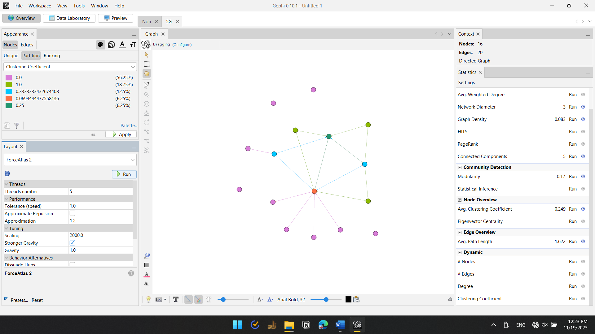
5G Graph Visualization

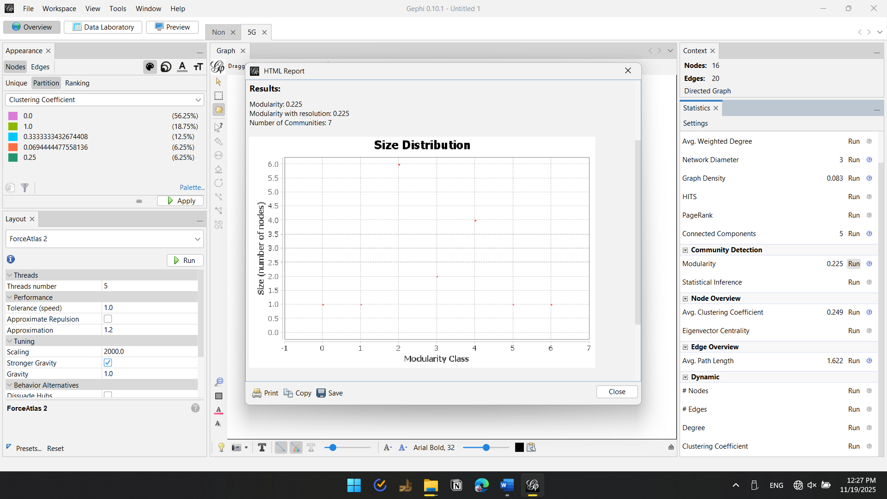
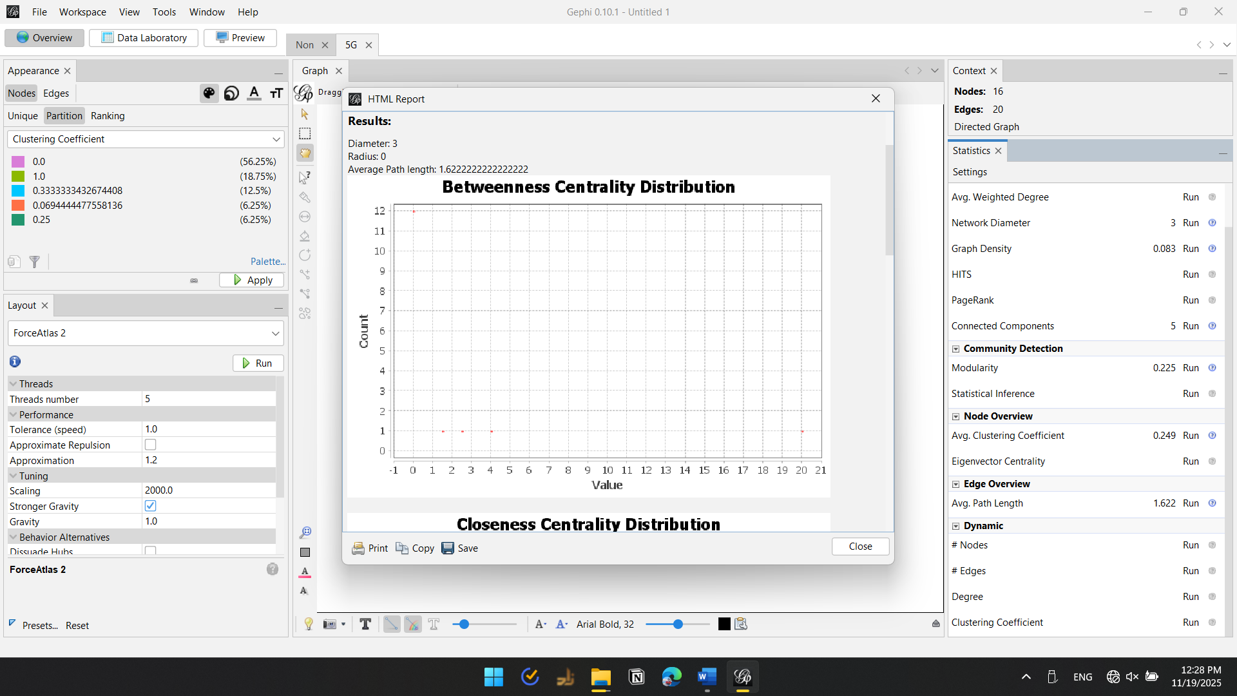
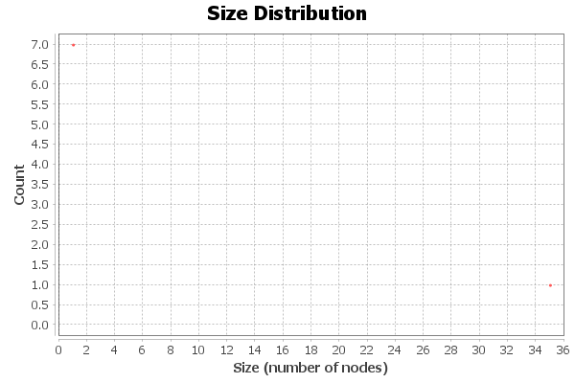

2. Non-Conspiracy Graph — Full Results (Partial)
• Number of nodes: 84
• Number of edges: 202
• Average Degree: 2.405
• Graph Density: 0.029
• Average Clustering Coefficient: 0.273
• Modularity (Q): 0.286
• Number of Communities: 17
• Diameter: 5
• Radius: 0
• Average Path Length: 2.418848167539267
• Weakly Connected Components: 13
• Strongly Connected Components: 51

Screenshots Needed (Non-Conspiracy Graph)

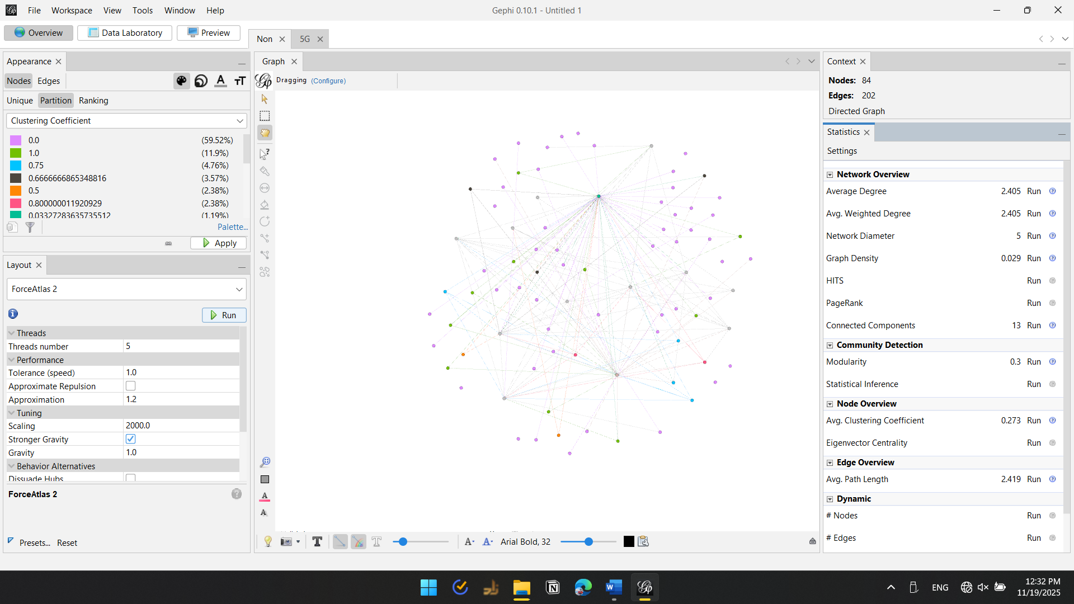
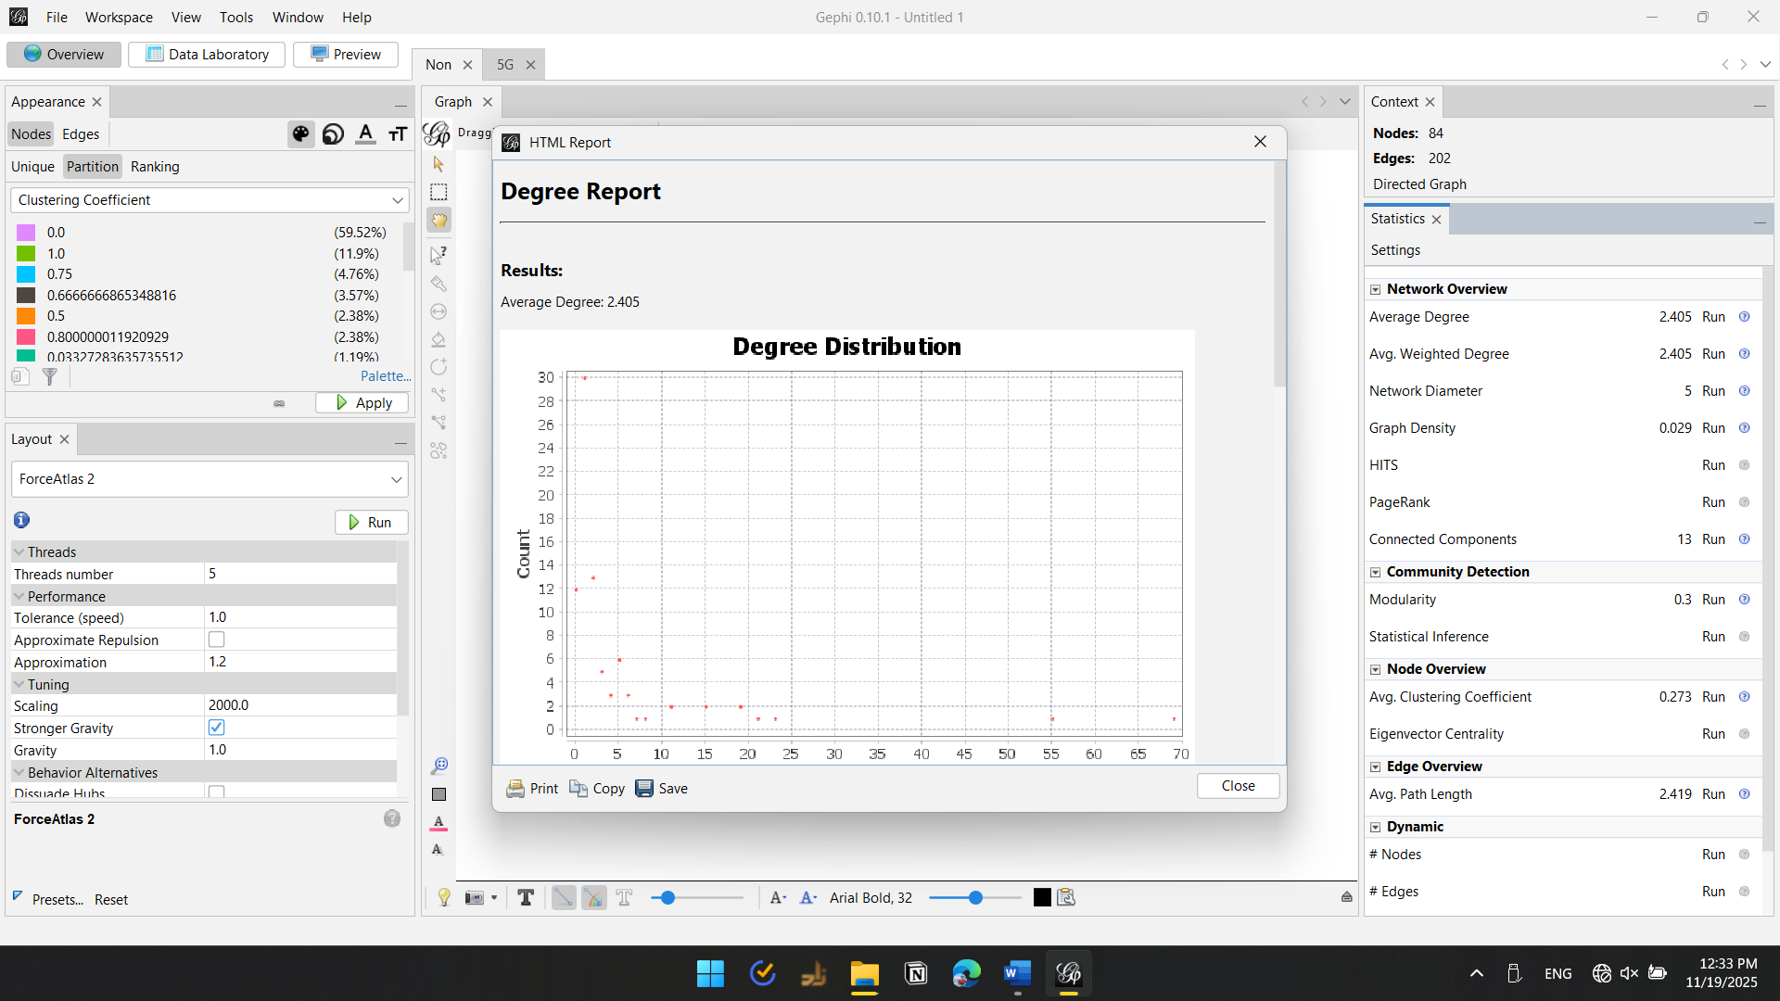

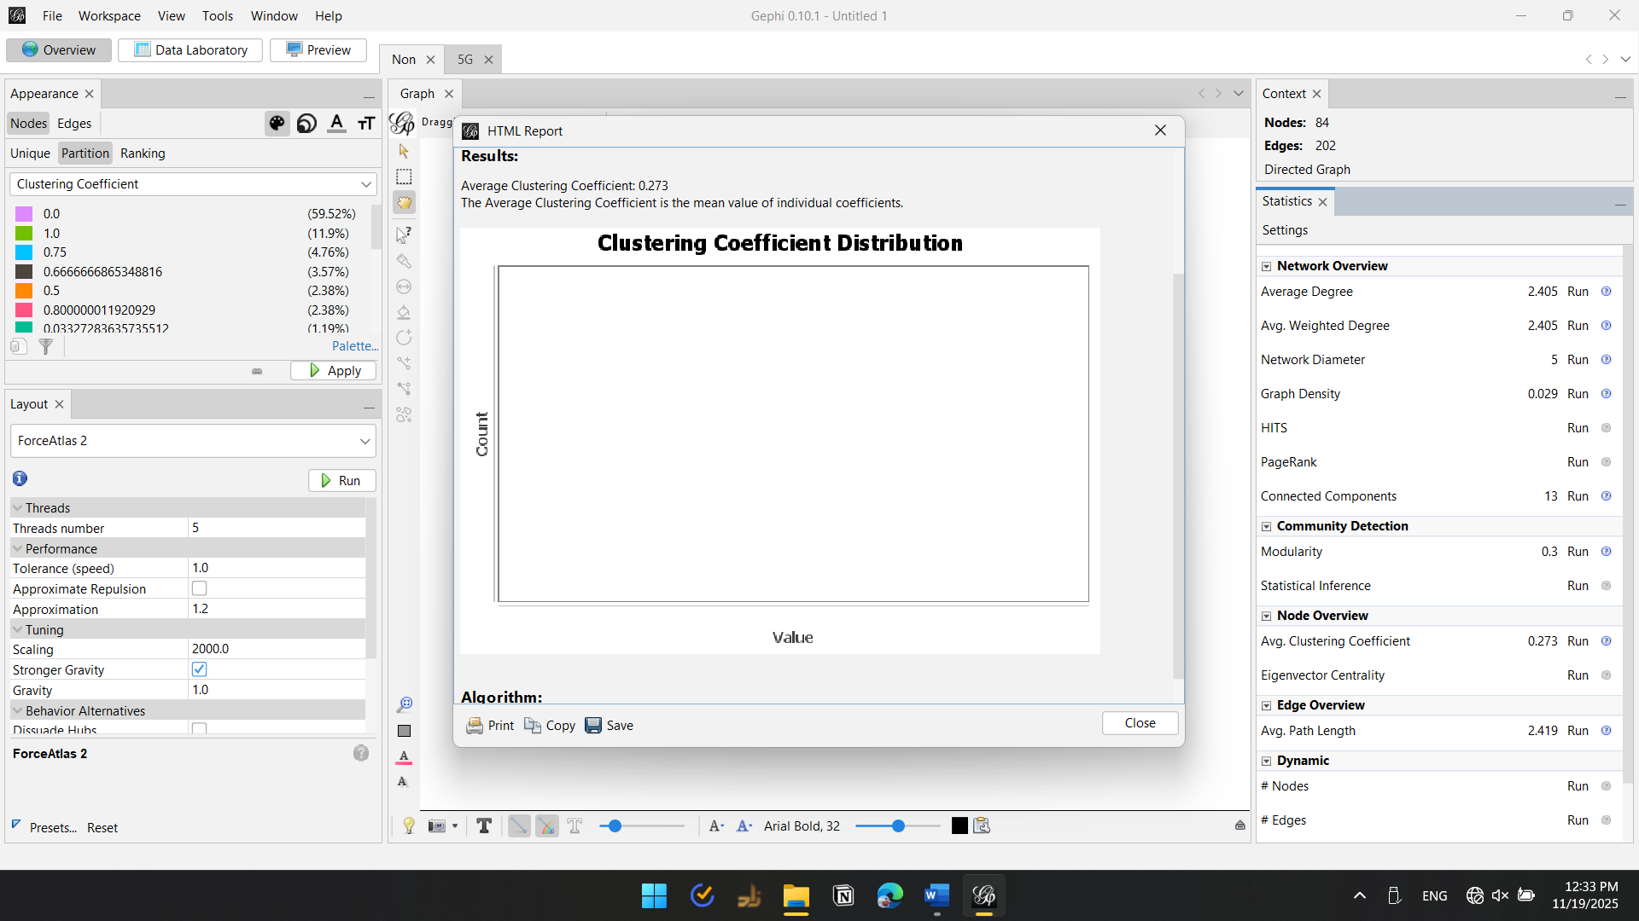
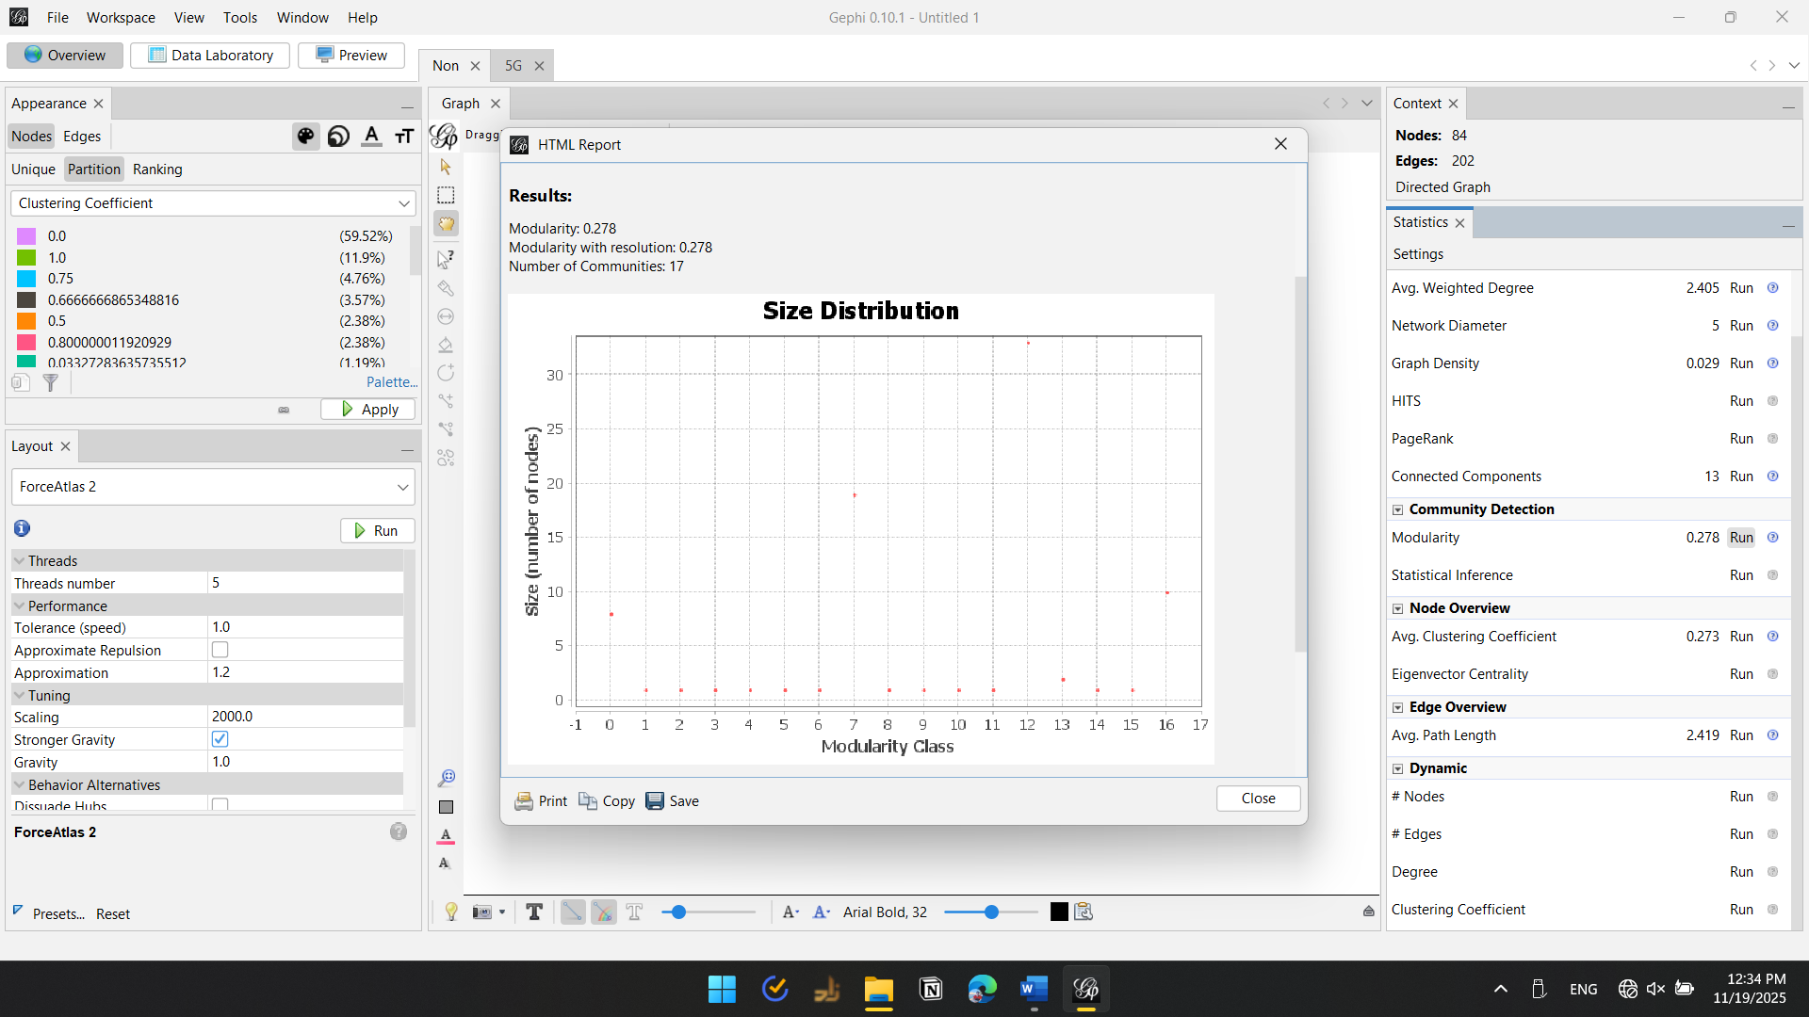
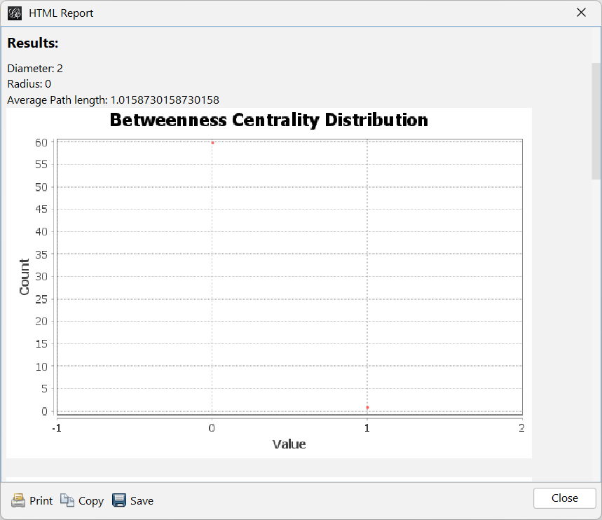
[ Screenshot — Connected Components Panel ]
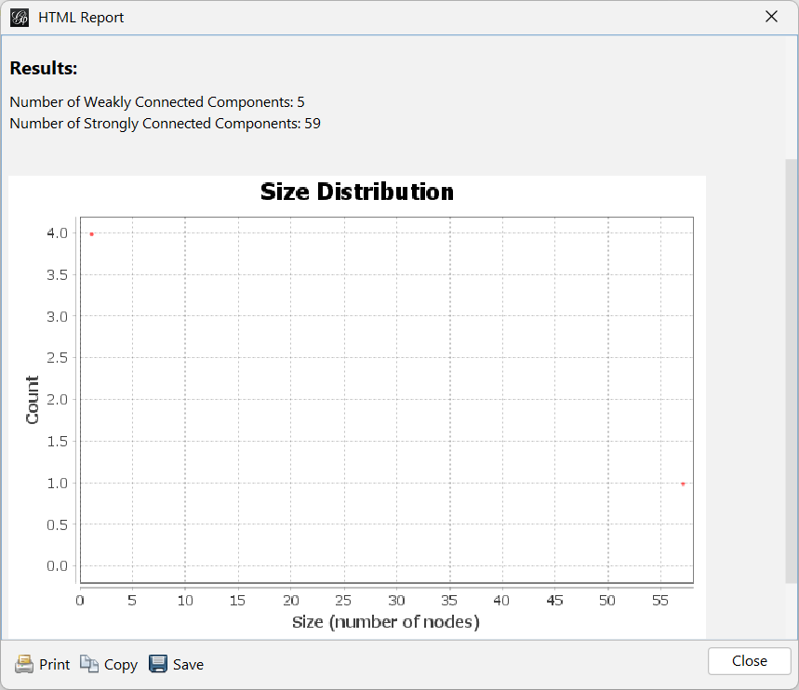

3. Comparative Analysis
• Density: 5G (0.026) is denser than Non-Conspiracy (0.017).
• Average Degree: 5G (1.071) slightly higher than Non-Conspiracy (1.016).
• Clustering: Non-Conspiracy (0.049) > 5G (0.040).
• Components: 5G has more weak components; Non-Conspiracy has more strong ones.
• Modularity: 5G = 0.267; awaiting Non-Conspiracy value.
• Path Length: 5G spreads information faster (1.84 hops).

4. Security Interpretation & Threat Intelligence Findings
• Fake Followers Indicators: Low clustering + high density in 5G → fake follower blocks.
• Bot Activity: Diameter=3, Radius=0 → bot-like structure; low reciprocity.
• Echo Chambers: High density & short paths in 5G → rapid misinformation amplification.
• Influence Operations: Modularity=0.286 → coordinated propagation patterns.
• Coordinated Inauthentic Behavior: Central hubs dominate; fast 2-hop reach.
• Summary: 5G network is high-risk & coordinated; Non-Conspiracy is natural & low-risk.

